Lab 4 Report

Authors:

Chase Vara, #2211740

Date: 10 March 2024

EE/CSE 474 Winter 2024

Introduction 2

System Design and Implementation 2

Code Structure 3

Discussion 4

Suggestions 6

Conclusions 6

References 7

Appendices 7

Total Number of hours Spent 7

# Introduction

The purpose of this lab was to gain experience using FreeRTOS to synchronize complex real-time hardware tasks and to combine the tools and knowledge gained throughout this course to create a novel project. After demonstrating basic competencies in FreeRTOS implementation during Part B, I pushed myself to create a project that leveraged multiple areas of knowledge I’ve stidied through my experience not only in this course, but throughout my ECE curriculum. Mainly, I wanted to do something involving signal analysis visualization. I chose to design and implement a real-time ambient audio frequency spectrum visualizer to achieve these objectives—and because I thought it would look cool. I was lucky to have chosen something I was enthused by because I did not know what I was getting myself into in terms of system complexity, hardware configuration, and debugging debauchery. Overall, it was a winding journey to arrive at a successful implementation capable of displaying 64 points of real-time audio spectrum data on an LED RGB strip, refreshed 22 times per second.

# System Design and Implementation

**Part B (FreeRTOS demonstration)**

Part B was organized as a FreeRTOS scheduler to achieve three primary tasks: Blink and LED (200ms on, 100ms off) continuously, play a song three times with times paused between plays, and perform five times Fast Fourier Transform (FFT) computations to report computation time to the user.

**Part C (Ambient Sound Spectrum Visualizer)**

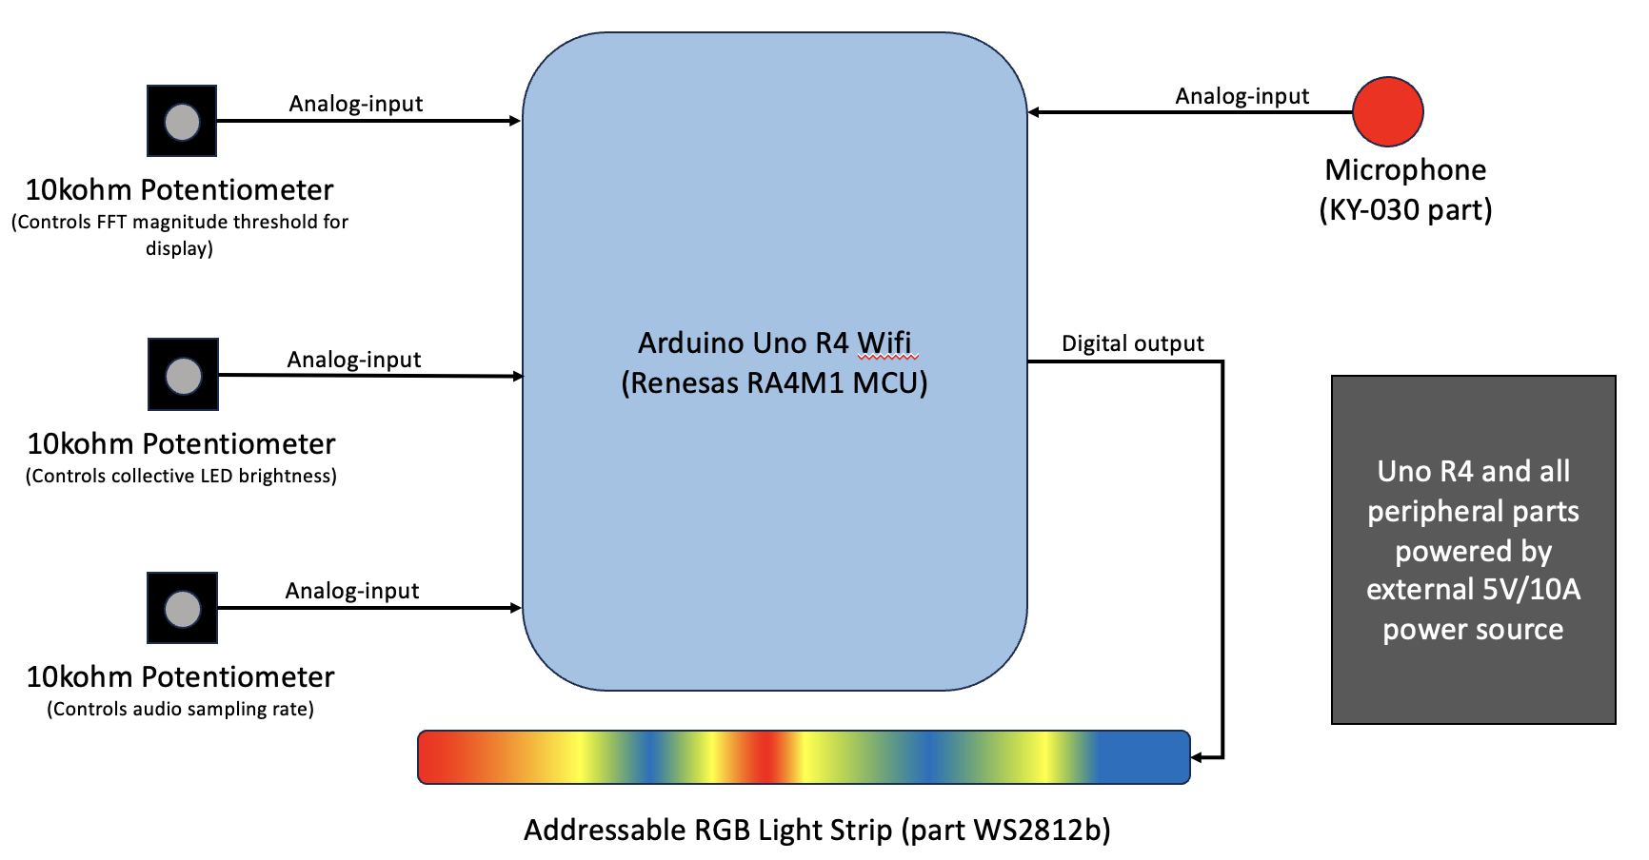

Figure 1: Hardware layout of ambient sound spectrum visualizer system.

The visualizer samples ambient audio from the environment, performs a Fast Fourier Transform on the sampled audio data, and displays the FFT (real component) by mapping frequency to LED position in an LED strip, and mapping a frequency component’s magnitude to an RGB color corresponding to a color-scale. This is performed at a rate of approximately 22 Hz (limited by processor speed) to achieve a human-perceived real-time spectrum visualization of the environment’s sound. The effect is a real-time “heat map” showing the ambient audio’s frequency signature.

The spectrum visualizer was designed with three key user features in mind: control of LED brightness, control of magnitude threshold for display of frequency data, and ability to adjust audio sampling rate. Additionally, the system was designed to be easily configurable for different color-scale schemes used to represent Fast Fourier Transform (FFT) magnitude data on the LED strip. Also, I architected the software to be easily extensible to different hardware platforms for future implementations.

This proof-of-concept software implementation has three key component subsystems: Audio sampling, FFT computation, and LED color computation and control. I chose to break out audio sampling functions and color computation and setting functions into separate files to make the main program agnostic to hardware (i.e. timer-counter registers used in audio sampling are specific to the RA4M1 microcontroller used in this implementation).

# Code Structure

**Part B (FreeRTOS demonstration)**

*part_b.ino*—Main Arduino sketch that houses FreeRTOS task definitions and runs the scheduler to synchronize operation of the Arduino Mega 2560 board hardware in real time.

*task_2.h, task_2.cpp, mario.h*—functions to run the playing of the beginning of the Mario theme song by manipulating the PWM frequency do drive output to a buzzer. Provides functions to configure the hardware for for task performance, along with options to configure timer-counter in CTC mode to manage the beat-frequency and tone changes, or to allow the client to manually manage the beat. *mario.h* contains the song tone data used to produce the sequence of tones for the song.

*timers.h, timers.cpp*—These set of functions provide a streamlined way to configure either an 8-bit counter (timer 2 specifially) or any of the 16-bit timer-counters in fast-PWM or CTC mode. Additional functions were developed to check for compare matches, reset compare flags, enable hardware output of timer signals, or stop/clean up timer-counters. Both sets of functions are provided to either set the timer-counter top values and prescaler settings directly or to set them automatically for a desired real-time frequency parameter.

**Part C**

*(Third-party libraries used:* *FreeRTOS, FastLED, arduinoFFT)*

*LEDSoundSpectrum.ino*—Main Arduino sketch that houses FreeRTOS task definitions and runs the scheduler to synchronize operation of the Arduino Uno Rev 4 Wifi board in real time.

*config.h*—A configuration header file to define macros for configuring *LEDSoundSpectrum.ino* to operate under various parameters, in debugging modes, and in the future, different hardware environments. This file is where the various FreeRTOS stack sizes and priorities, color scale selection, timing parameters, and hardware configuration parameters live, making it easy to develop and debug the variously aspect of the system.

*audio_sampling.h, audio_sampling.cpp*—defines the configuration function (for setting up a hardware timer on the RA4M1) and sample function to sample an analog input at a given parameter sample rate, for a parameter number of samples. This makes the audio sampling configurable to the specifications and capabilities of the larger system.

*WS2812b_colorscale.h, WS2812b_colorscale.cpp*—Defines functions that use the FastLED library to drive a WS2812b RGB LED strip. Performs relative mapping of input data values (FFT magnitudes) to a color scale, enact global brightness setting (set by user), and adjusts mapping to set values below a parameter threshold (set by user) to the low color-value.

*color_scales.h*—defines several macros for arrays of 12-bit RGB hexadecimal color values composing color scale schemes. The macros are used by config.h to compile the software for a desired color scheme.

# Discussion

I took a ground-up, iterative approach to designing and implementing the components of this system, first assembling simple Arduino sketches to test and validate input/output of the various parts involved, then combining these validated parts into larger subsystems. One technique that I gained just from reading others’ library code during research and design was conditional compilation. I employed this in my code to turn debugging output on or off for different parts of the software simply by commenting out macros in the config file. This was very helpful as I navigated through iterations of debugging various components of the whole system and minimized the risk of accidently manipulating functioning code while inserting or deleting debug statements.

Something that I underestimated was the time it would take to learn a new MCU environment to be able to use the RA4M1’s peripheral general PWM timers to time audio sampling. The hardware abstraction layer provided by Renesas for this 32-bit architecture (the MCU relies on an ARM Cortex M4 as its processor) is vastly different than that for Atmel Mega 2860 that we got used to configuring in other labs. An example of this is the digging I had to do to discover that, on reset, the controller enters low-power mode, disabling all peripherals. There is a master register bit that must be set to enable peripheral timers. The challenge to discovering nuances such as this is that the Uno R4 is relatively new (Summer 2023), so online documentation of other’s experiences configuring the MCU for niche applications is sparce.

The most demanding software design task was setting the FreeRTOS priorities and stack sizes for my tasks. The first step in approaching this intelligently was digging into the Uno R4’s specific FreeRTOS configuration file to enable the stack high-water mark reporting function. Repeatedly, I kept running out of RAM to manage the various stack sizes of my tasks. One solution that helped me reduce stack size was to take advantage of the Uno R4’s FreeRTOS memory management scheme setting (which uses FreeRTOS’s heap_4.c) to allocate the system’s various shared data arrays and variables to the reserved FreeRTOS heap using the pvPortMalloc() function. I also found the GNU addr2line function invaluable to converting binary fault data into filenames and line numbers for debugging stack faults.

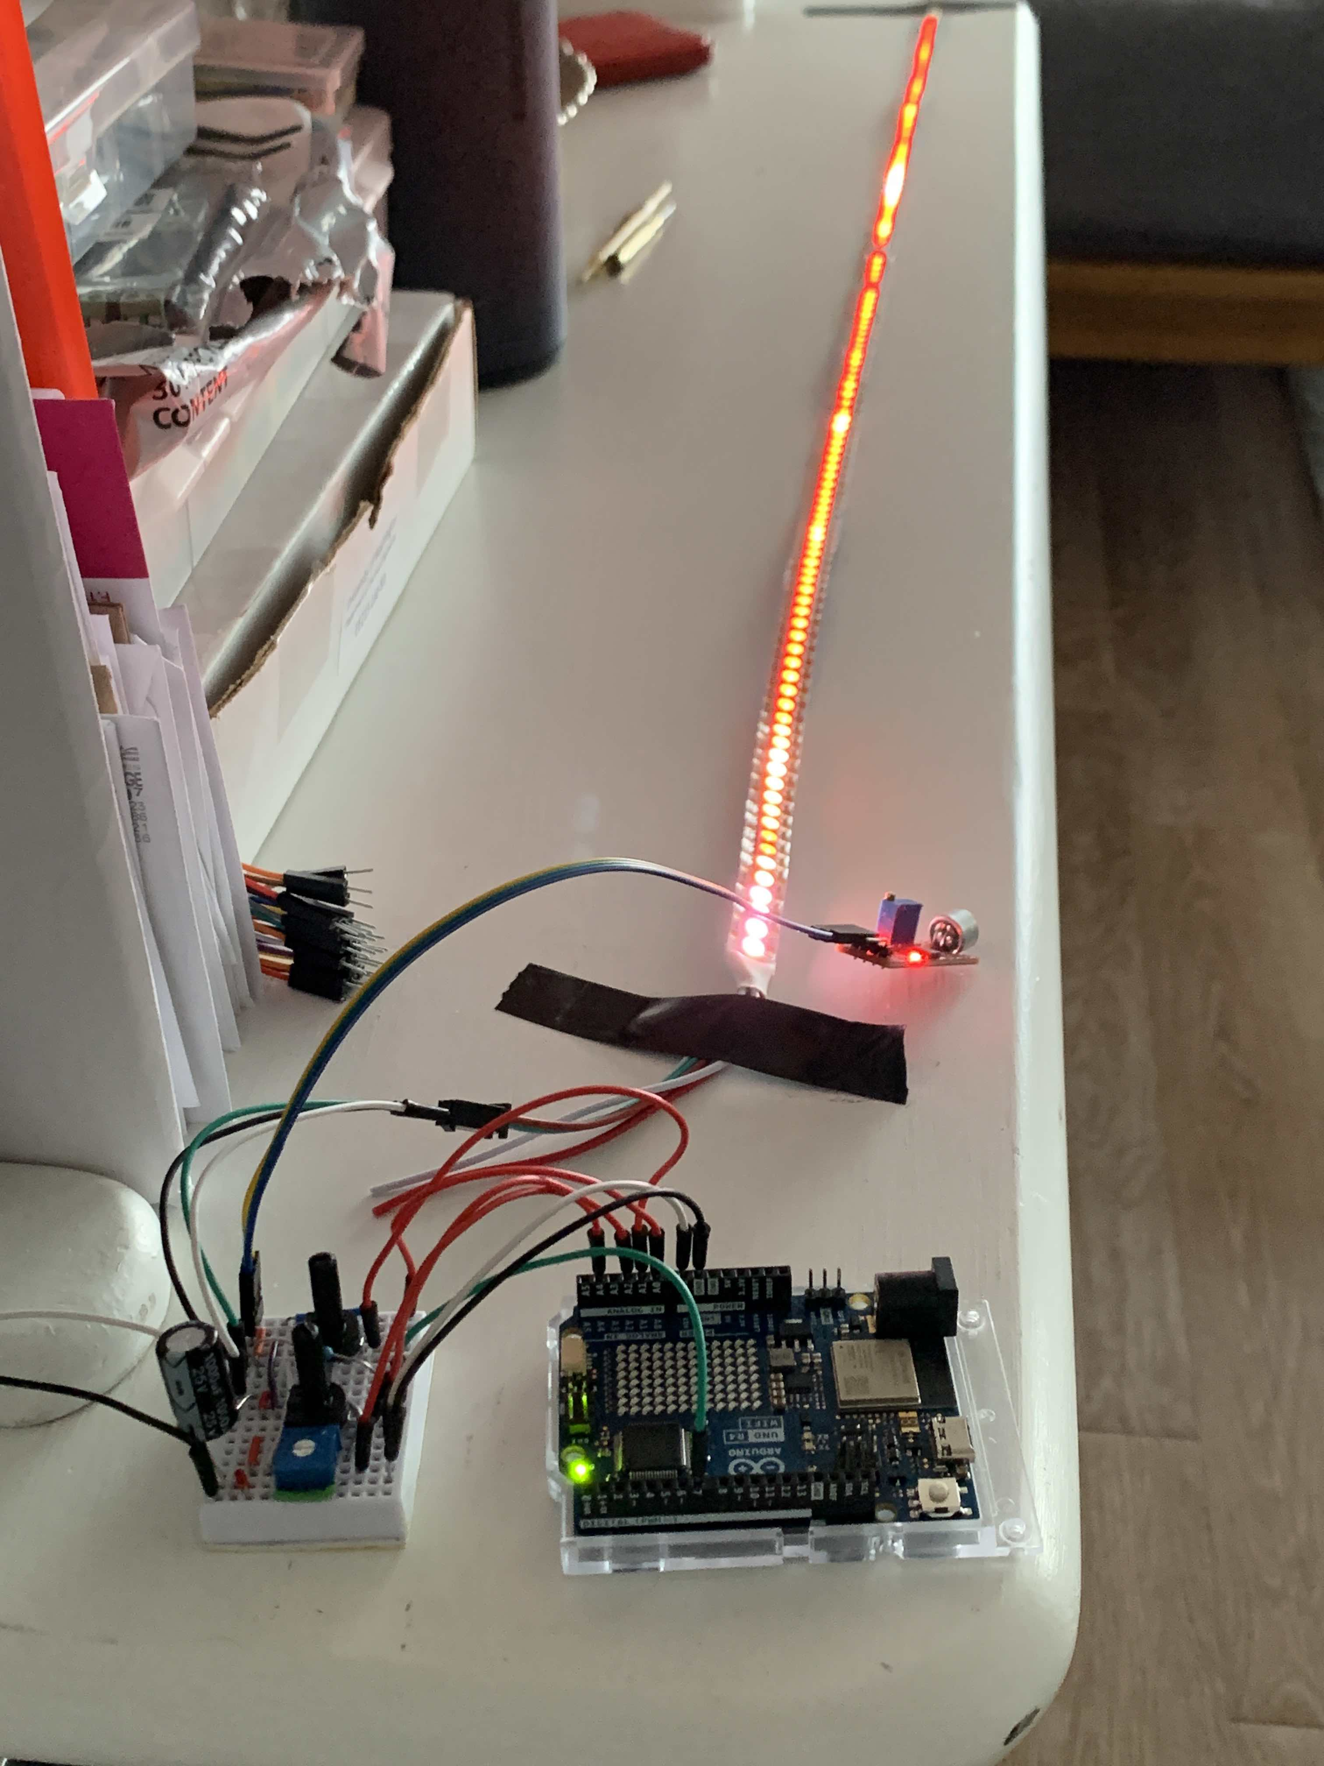

Figure 2: System operations, depicting the Uno Rev 4 Wifi board, with user inputs from potentiometers (left), and display output to the WS2812b RGB LED strip (top). The microphone KY-030 part is pictured to the right of the LED strip. Not picture is the 5V/10A power DC power supply. A 1000-microF capacitor was used between power input ground and active to protect against surges during power-up. A 300-ohm resistor was placed in series between the digital output from the board and the control input to the LED strip to limit current flow.

I also experienced some interesting aspects of signal analysis while implementing this design. During testing of the FFT task, I repeatedly kept seeing low-end spectrum components have values that were orders of magnitudes larger than the rest of the spectrum. What I realized was this was the DC component of the audio samples fed into the FFT computation—a function of the gain setting of the microphone. I was able to use the arduinoFFT library’s DCRemoval function to calculate the and remove this component from the FFT results.

Another interesting aspect discovered by the end of the design phase was the effect of adjusting sampling rate. My original intention with this feature was to allow the user to adjust the maximum frequency displayed. This was the wrong approach, however, as reducing the sampling rate introduces aliasing of high-frequency components over a lower-frequency spectrum. Because of this, I switched out the potentiometer to be trimmer-tool adjustable part, rather than a knob-adjustable one, so that I could use the setting as a tuning feature rather than a normal user feature. The correct approach would have been to perform a much larger N-point FFT, then allowing the user to adjust the mapping of that FFT to the comparatively fewer number of LEDs. This approach will require further optimization or different hardware, as I could only manage a maximum of a 128-point FFT amidst the RAM and timing constraints of the whole system.

# Suggestions

My only suggestion would be to require project proposal submissions a week earlier than they occurred during this iteration. This would have forced me to start exploring hardware and parts a little earlier and would have made the research phase more structured.

# Conclusions

This was a tremendously rewarding project to work on. The opportunity to focus on design just as much as implementation is a rarity in the undergraduate ECE curriculum. I felt that this was an excellent culmination of the vast amount knowledge we’ve spent ten weeks acquiring through this course. A valuable aspect of this project was the opportunity to explore different hardware and architectures to solve problems as they came up during the design process. Going through the motions of researching, reading documentation, testing, and debugging unfamiliar parts and problems made me understand my designed system to an intensely granular level of detail. The added benefit of my chosen project was the opportunity to reinforce my foundation in signals analysis knowledge gained in other courses.

# References

[1] “Renesas RA4M1 Group User’s Manual: Hardware.” Renesas Electronics. Rev.1.10, September 2023. Accessed 29 February 2024. https://www.renesas.com/us/en/products/microcontrollers-microprocessors/ra-cortex-m-mcus/ra4m1-32-bit-microcontrollers-48mhz-arm-cortex-m4-and-lcd-controller-and-cap-touch-hmi#documents

[2] “How To Control WS2812B Individually Addressable LEDs using Arduino.” How-to Mechatronics. Accessed 2 March 2024. https://howtomechatronics.com/tutorials/arduino/how-to-control-ws2812b-individually-addressable-leds-using-arduino/

[3] “Using GPT to Drive a Step Pulse.” Arduino Forum. Accessed 1 March 2024. https://forum.arduino.cc/t/using-gpt-to-drive-a-step-pulse/1196139/3

[4] “r/FastLED: Uno R4 Support.” Accessed 2 March 2024. https://www.reddit.com/r/FastLED/comments/14trdku/uno_r4_support/

[5] “GNU Operating System: GNU Binutils.” Free Software Foundation. Accessed 4 March 2024. https://www.gnu.org/software/binutils/binutils.html

[6] Hayk An. “Scale: a generative way to create color scales.” Accessed 7 March 2024. https://hihayk.github.io/scale/#4/6/50/80/-51/67/20/14/1D9A6C/29/154/108/white

[7] “FastLED Library” Accessed 2 March 2024. http://fastled.io/docs/index.html

# Appendices

## Total Number of hours Spent

70 hours